**Leg 8 4miles. Approx Start time 3:00pm**.

**Start** - Buckden – where the DW Path emerges onto the road (Nearest Postcode – BD23 5JX)

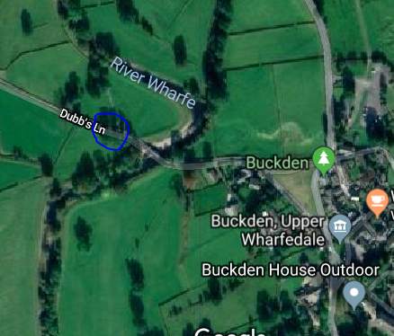

**Finish** – KettlewellJust near the bridge where the DW path crosses (Nearest Postcode – BD23 5QZ)

