**Leg 6 6.7miles. Approx Start time 12:30pm**.

**Start** - Holme Hill layby at start of long climb over Dodd Fell. (Nearest Postcode – LA6 3AT)

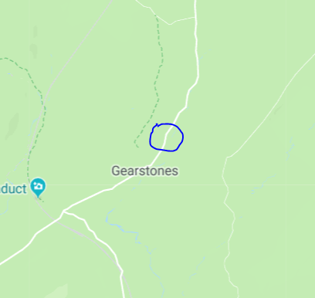

**Finish** - Beckermonds Where track ends and DW path starts the Wharfe (Nearest Postcode – BD23 5JL)

