**Leg 5 9miles. Approx Start time 10:40am**.

**Start** - Dent – where DW path emerges onto the road (Nearest Postcode – LA10 5QN)

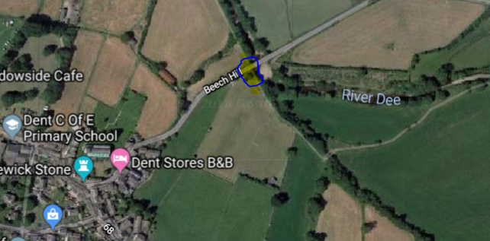

**Finish** - Holme Hill layby at start of long climb over Dodd Fell. (Nearest Postcode – LA6 3AT)

