**Leg 4 4.8miles. Approx Start time 9:40am**.

**Start** - Layby over the Bridge at Millthrop (Nearest Postcode – LA10 5SJ)

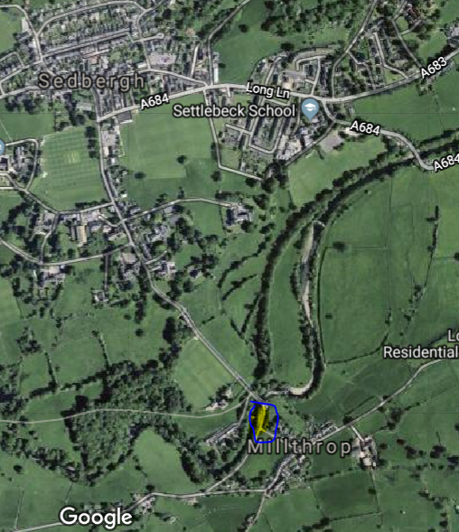

**Finish**- Dent – where DW path emerges onto the road (Nearest Postcode – LA10 5QN)

