**Leg 3 6.7miles. Approx Start time 8:25am**.

**Start** - Crook of Lune near nowhere in particular! (Nearest Postcode – LA8 0BW)

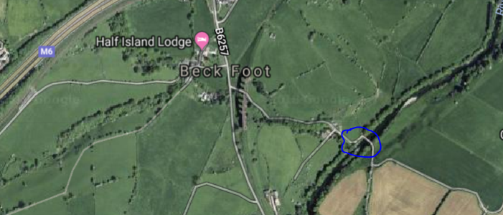

**Finish**- Layby over the Bridge at Millthrop (Nearest Postcode – LA10 5SJ)

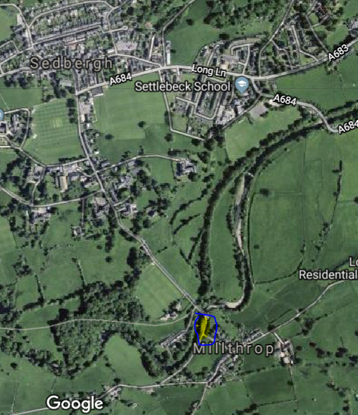

Difference in start point to nearest postcode.

