**Leg 2 9miles. Approx Start time 6:30am**.

**Start** - Bowston/Burnside – By garage/phone box where DW path enters onto the road (Nearest Postcode – LA8 9HG)

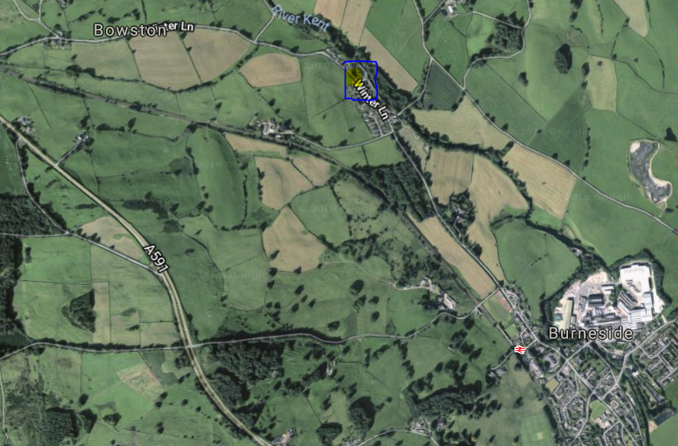

**Finish**- Crook of Lune nr nowhere in particular! (Nearest Postcode – LA8 0BW)

