**Leg 11 3.6miles. Approx Start time 5:30pm**.

**Start** – on another ‘B..’ Bridge – Burnsall (Nearest Postcode – BD23 6BU)

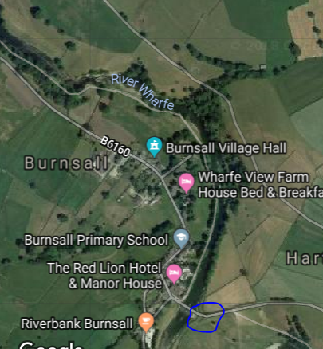

**Finish** – Barden – Guess what, another Bridge! (Nearest Postcode – BD23 6AT)

