**Leg 10 3.5miles. Approx Start time 5:00pm**.

**Start** - Grassington – Before the Bridge – somewhere on the way out of Grassington (Nearest Postcode – BD23 5NJ)

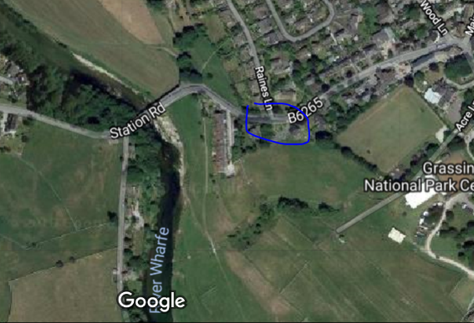

**Finish** – on another ‘B..’ Bridge – Burnsall (Nearest Postcode – BD23 6BU)

