**Leg 1 8.8miles. Start time 5am**.

**Start** - Bowness Pier PICK A PEBBLE FROM THE BEACH TO ACT A RELAY BATON LA23 3HQ

Dalesway actually starts at the end of Brantfell Road. LA23 3AT

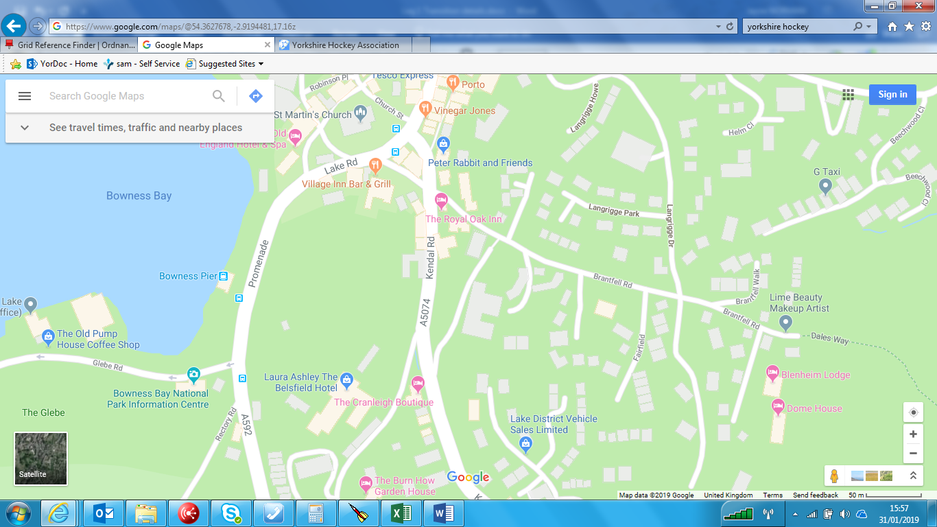

**Finish**- Bowston/Burnside – By garage/phone box where DW path enters onto the road (Nearest Postcode – LA8 9HG)

