Town circular (forwards & backwards)
Longer 7.2 miles: http://www.gmap-pedometer.com/?r=2293833
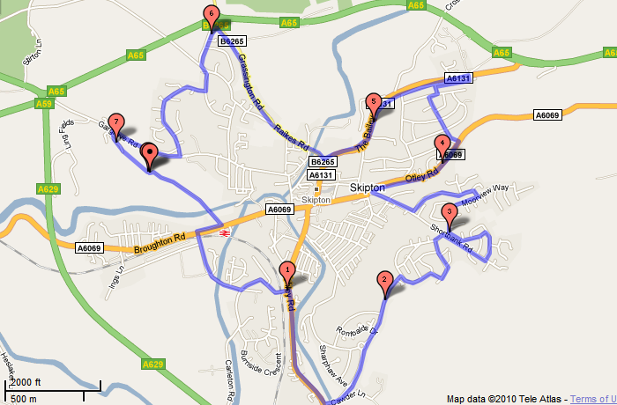
Town circular (forwards & backwards)
Medium 5.35 miles: http://www.gmap-pedometer.com/?r=4109817
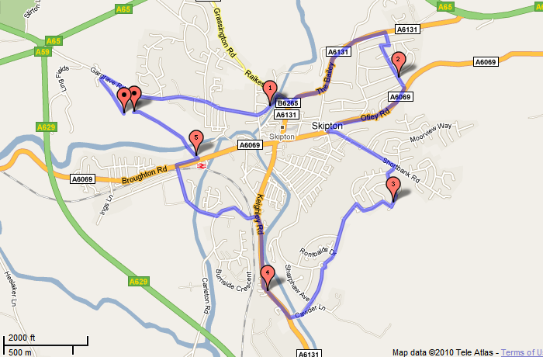

Town circular (forwards & backwards)
Shorter 3.48 miles: http://www.gmap-pedometer.com/?r=4111527
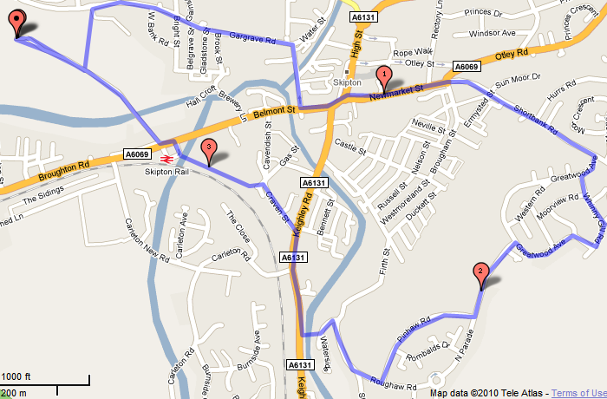

Central Town
Longer 6.5 miles: http://www.gmap-pedometer.com/?r=2293871
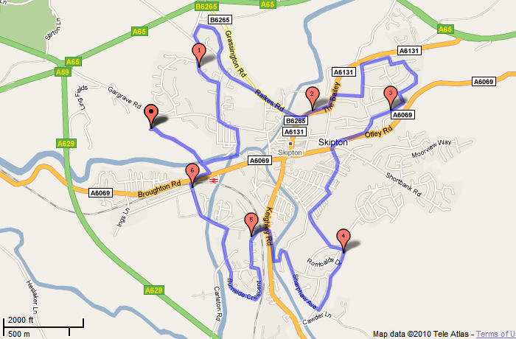
Central Town
Medium 4.83 miles: http://www.gmap-pedometer.com/?r=4109831
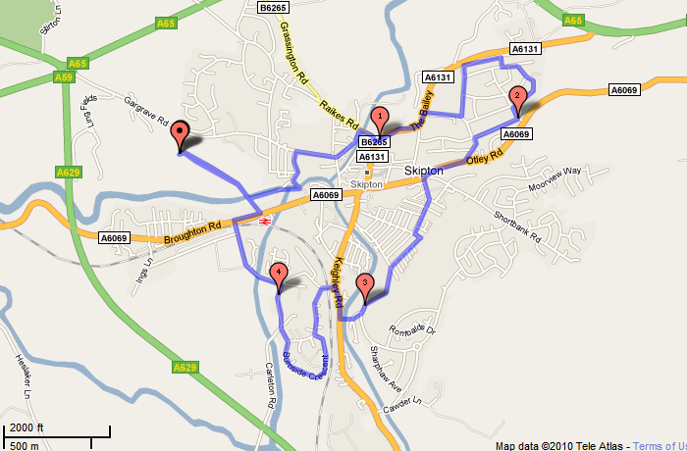
Central Town
Shorter 3.42 miles: http://www.gmap-pedometer.com/?r=4111550
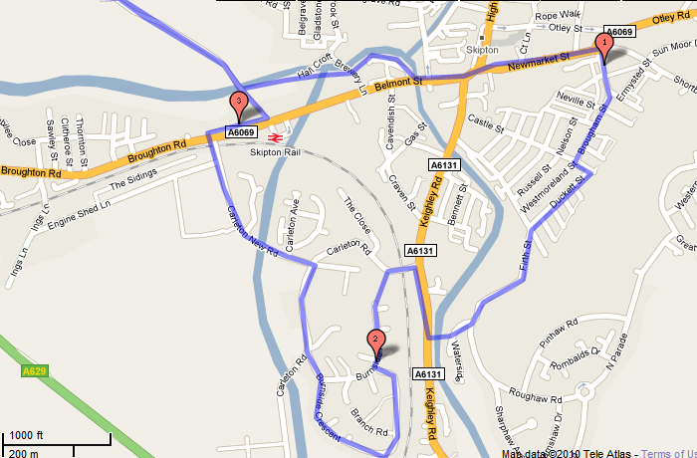

Embsay / Eastby
Longer ‘last light’: 8.25: http://www.gmap-pedometer.com/?r=2293850
Medium ‘Embsay Loop’: 6.55: http://www.gmap-pedometer.com/?r=2303704
Shorter ‘Cavendish’ 5.16 miles:
Shorter ‘Past top of Bailey’ 3.3 miles:
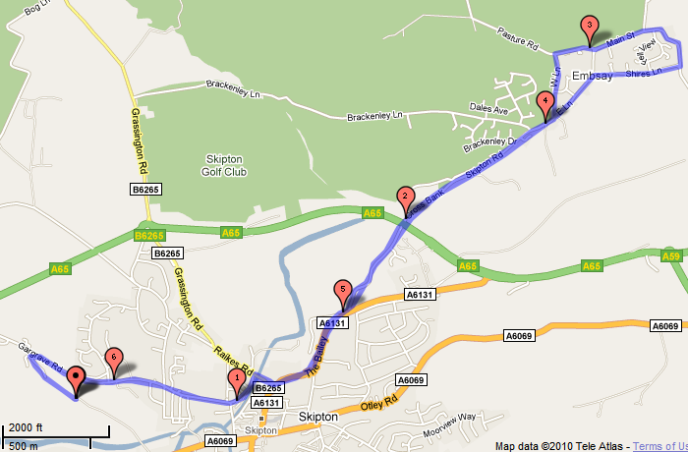

North-East town
Longer 7.3 miles: as medium plus Embsay loop
Medium 5.8 miles: http://www.gmap-pedometer.com/?r=4109571
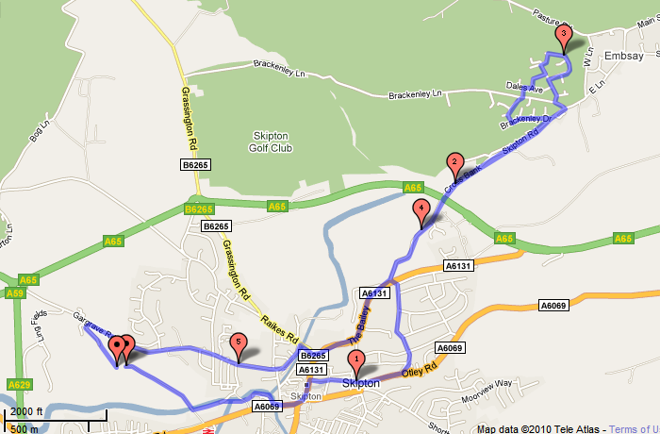

North-East town
Shorter 3.1 miles: http://www.gmap-pedometer.com/?r=4109589
